**Ex. No. 6 Date:25.10.2020**

**Design of Single phase Half wave**

**and Full wave Rectifiers**

**Aim:**To design a circuit to perform single-phase half wave and full wave rectifier using

OrCAD Pspice software.

**Apparatus/Tool required:**

ORCAD / PSpice simulator -> **Diode Library - D1N4002/4007,**

**Source Library – Vsin & Ground (GND) – 0(zero)**

**Analog Library – R**

Simulation Settings: **Analysis Type - Time Domain**

**Run to time: 40ms (for 2 cycles)**

**Circuit Diagram:**

**Single phase Half – wave Rectifier**



**Single phase Full – Wave Rectifier**



**Theory:**

**Half – wave Rectifier:**

A half wave rectifier is defined as a type of rectifier that only allows one half-cycle

of an AC voltage waveform to pass, blocking the other half-cycle.

**Full – wave Rectifier:**

The circuits which rectify both the positive and negative half cycles of an input

alternating waveform, the rectifiers are referred as full wave rectifiers.

**Circuit and Output of a Half-wave Rectifier:**

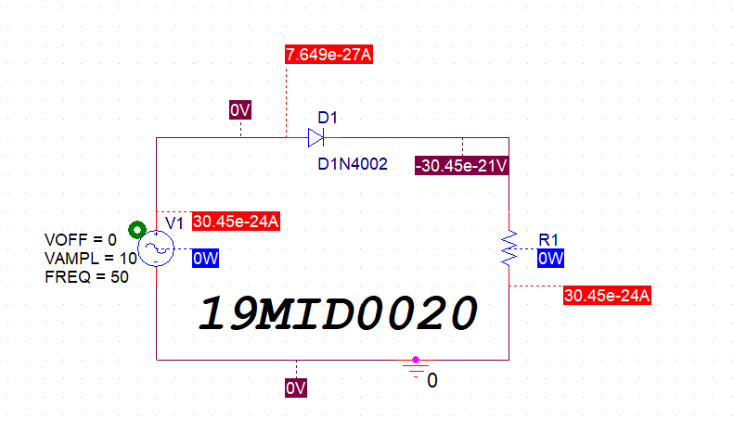

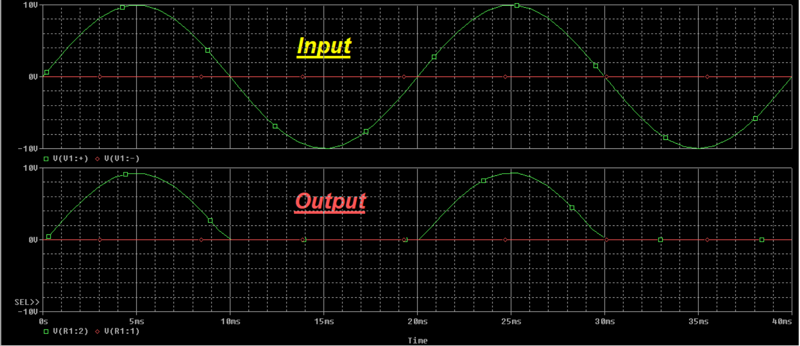

**Circuit and Output of Full-wave rectifier:**

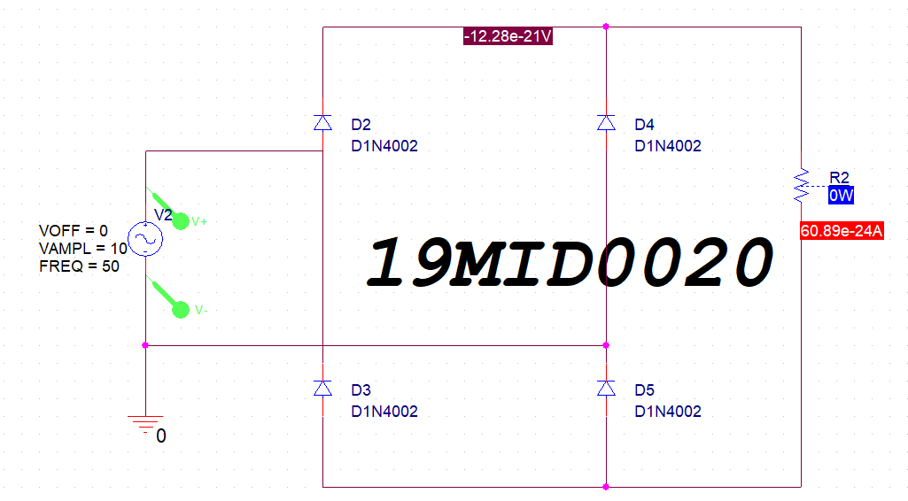

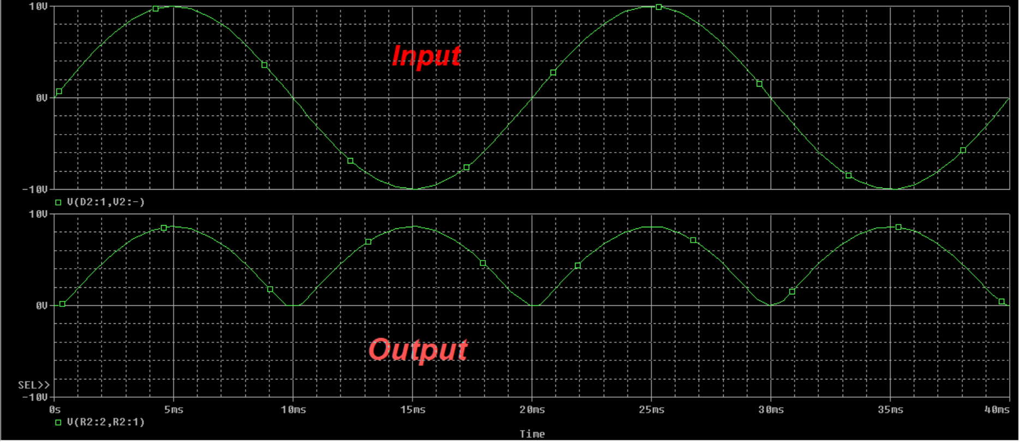

**Procedure:**

✓ Design the circuit using the software

✓ Create simulation profile of type “Time Domain” and set the value of Run time as 40ms

✓ Place the Voltage differential marker before and after the source to get the input AC

wave simulated graph

✓ Similarly place it before and after the Load Resistor and run it to get the output DC wave

graph.

**Model Graph:**

**V**

**Time**

**VIN**

**VOUT for HWR**

**VOUT for FWR**

**Result:**

The simulation of Single-phase Half wave and Full wave rectifier is performed using

OrCAD Pspice software.

**Inference:**

✓ Rectifier coverts a AC source to DC form.

✓ Half wave rectifier converts the positive half cycles of the AC to DC form

✓ Full wave rectifier converts both the positive and negative half cycles of the AC

source to DC source.

**Reg. No: 19MID0020 Name: Prashanth.S Date: 25-10-2020**